Pécs2010 - European Capital of Culture

AFTER THE CULTURAL CITY

New Positions for Culture in Urban Development
International Conference
Pécs, 2010. September 24-25.

After the Cultural City is an international conference on new questions and issues of culture-led planning, urban development, architecture and the creative industries. In recent years the spatial and operational context of the urban public has been redefined by both the economic and political transformations of the global economic crises and the simultaneously growing importance of technology and networks in urban systems. These processes have created new relationships between centre and periphery, built spaces and their users, also offering new roles for culture and innovation in architectural, institutional and infrastructural development.

The program features leading international professionals presenting cutting edge thinking, case studies and methods, envisioning new strategies for culture-led development and interdisciplinary cooperation in various practices.

Confirmed keynote speakers:
Franco Bianchini, Juan Herreros and Saskia Sassen.

Invited lecturers include:
Matej Bejenaru, Bodó Balázs, Bryan Boyer, Fabien Girardin, Adam Greenfield, Bas van Heur, Sabine Knierbein, Bert van Meggelen, Fabrice Raffin, Dominique Rouillard, Richard Russell, Nada Svob-Dokic, Jakub Szczesny, Kai Vöckler.

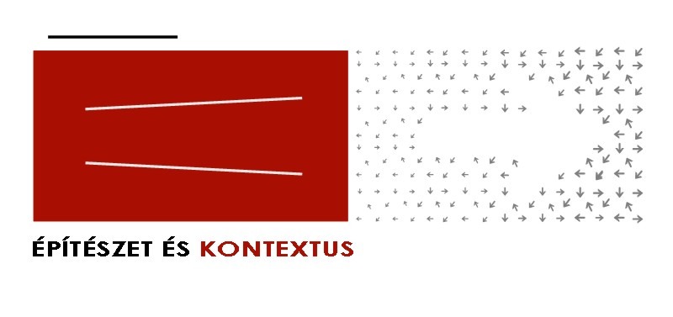
More information:
- www.ek2010.hu

Responsible for thematic:
- Samu Szemerey and Levente Polyák

Partners:
- South-Transdanubian Chamber of Architects
- Mihály Pollack Faculty of Technology, University of Pécs
- Department of Communication and Media Sciences, UP
- Association of Hungarian Urbanists

Sponsors:
- Pécs2010 Menedzsmentközpont Nonprofit Kft.
- Hungarofest Nonprofit Kft.
- Hungarian Chamber of Architects
- Hungarian Association of Architects

