Pécs2010 - European Capital of Culture

AFTER THE CULTURAL CITY

New Positions for Culture in Urban Development
International Conference
Pécs, 2010. September 24-25.

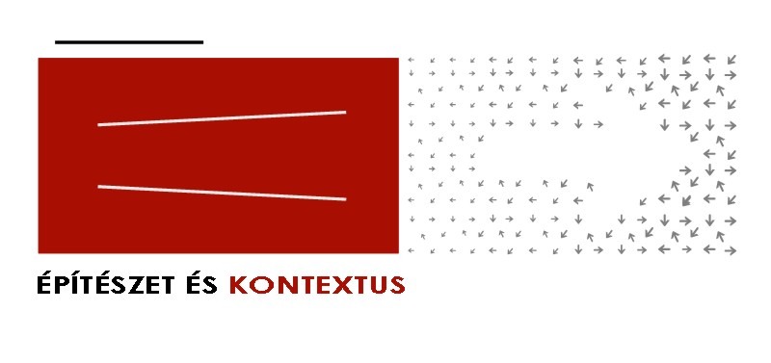
What are the main issues of culture-led development at the end of the decade? Where is culture located and how can it be used in architectural, policy and management models? What is the role of culture-led development in small cities and on the peripheries?

Since the Hungarian city of Pécs won the title of European Capital of Culture, thus entering the EU's culture-led urban development framework, profound transformations have been taking place both within and beyond the city. The global financial crisis and the resulting recessions of the last two years have upset the basic concepts of post-industrial urban development, which previously had seen cultural industries as pivotal channels through which economic growth based on speculative real estate development could be brought back into the city. Culture-led development policies need to be revisited not only because their economic bases have faded away, but also because the profound differences in urban scales as well as geopolitical contexts have so far largely been ignored in their implementations.

The exploding technological progress of the last two decades, unfolding parallel to the deregulation and globalization of financial and real estate markets, has also profoundly transformed the relationship of cities and their inhabitants. Whether in personal or working environments, physical built space and technology do not exist anymore as parallel universes but instead as intertwined, symbiotic, augmented realities that define the ways culture is consumed and used in the everyday. The key issue of culture-led development is thus more and more how cities design and make accessible their physical and digital infrastructures, and what roles of regulation and control communities and individuals are provided therein. The technological transformation of public space and communities also affects architecture, cultural management, urban institutions and development policies. The problems of peripheries are therefore not only geographical but also technological, which raises the question of innovation and policy limits in developing regions.

The goal of the ‘After the Cultural City’ conference is to rethink the possibilities of culture-led urban development in the post-crisis economic, political and social climate, to assess its limits, its remaining and new relevant targets in Central and South East Europe and to outline new possible ways of development for Pécs and other cities in the region. The program, featuring leading international theorists, professionals, architects, planners, policy makers, sociologists and historians is organized around questions related to the international transfer of concepts and policies, the legacy of the Creative City after the economic crisis, the relationship of infrastructures and new technologies to the access to culture, and the role of cultural innovation in peripheral neighborhoods and regions. By presenting cutting edge research and critical approaches as well as methods and best practices we invite strategic collaboration between scholars, policy professionals, decision makers and designers.

Confirmed keynote speakers: Franco Bianchini, Juan Herreros and Saskia Sassen. Invited lecturers include Matej Bejenaru, Bodó Balázs, Bryan Boyer, Fabien Girardin, Adam Greenfield, Bas van Heur, Sabine Knierbein, Bert van Meggelen, Fabrice Raffin, Dominique Rouillard, Richard Russell, Nada Svob-Dokic, Jakub Szczesny, Kai Vöckler.

More information:
- www.ek2010.hu

Responsible for thematic:
- Samu Szemerey and Levente Polyák

Partners:
- South-Transdanubian Chamber of Architects
- Mihály Pollack Faculty of Technology, University of Pécs
- Department of Communication and Media Sciences, University of Pécs
- Association of Hungarian Urbanists

Sponsors:
- Pécs2010 Menedzsmentközpont Nonprofit Kft.
- Hungarofest Nonprofit Kft.
- Hungarian Chamber of Architects
- Hungarian Association of Architects

