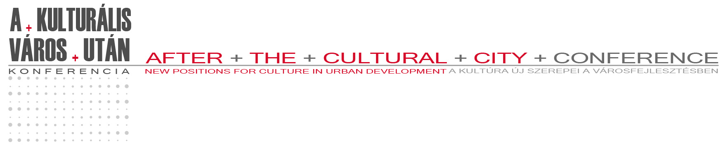

REGISTRATION FORM

Colleague1:
SURNAME:
FIRST NAME:
PHONE NUMBER:
E-MAIL:
MEDIA:
POSITION (journalist, photographer, cameraman, reporter, editor):

Colleague2:
SURNAME:
FIRST NAME:
PHONE NUMBER:
E-MAIL:
MEDIA:
POSITION (journalist, photographer, cameraman, reporter, editor):

PREVIOUS AND SCHEDULED PRESS RELEASES CONCERNING „AFTER THE CULTURAL CITY” CONFERENCE:

Please send the completed form to the following
e-mail address or fax number.
The organizing committee of the conference will inform you
on the evaluation of accreditation until September 10 2010.
e-mail: ek2010@pcongress.hu
fax.: +36-72-327572
www.ek2010.hu
www.pcongress.hu

